H.T No
Regulations:
A15

Sreenidhi Institute of Science and Technology
(An Autonomous Institution)
Code No: 5H315 Date: 08-Oct-2020 (FN)

B.Tech II-Year I-Semester External Examination, October - 2020 (Supplementary)
Engineering Mathematics-III (Common to All Except BT)

Time: 2 Hours Max.Marks:75

Note: a) No additional answer sheets will be provided.
b) All sub-parts of a question must be answered at one place only, otherwise it will not be valued.
c) Missing data can be assumed suitably.

ANSWER ANY FIVE QUESTIONS. EACH QUESTION CARRIES 15 MARKS.

1. | a) | Using bisection method find the approximate root of the equation  x³-x-1=0 . | [8M]
 | b) | Find a real root of the equation x log₁₀x-1.2=0 by Newton-Raphson method correct up to three decimal places. | [7M]
2. | a) | Apply Gauss-forward central difference formula and estimate f(32) from the following table | [8M]
  x | 25 | 30 | 35 | 40
  f(x) | 0.2707 | 0.3027 | 0.3386 | 0.3794
 | b) | Find the interpolating polynomial f(x) from the table | [7M]
  x | 0 | 1 | 4 | 5
  y | 4 | 3 | 24 | 39
3. | a) | Find y(0.2) using picard’s method, given 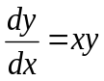,y(0)=1 taking h=0.1. | [8M]
 | b) | Solve the following using R-K fourth order method y¹=y-x,y(0)=2,h=0.2. | [7M]
4. | a) | Express J₅(x) interms of J₀(x) and J₁(x). | [8M]
 | b) | Evaluate 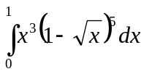 | [7M]
5. | a) | Using Cauchy -Residue theorem evaluate 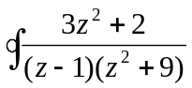 where C:Iz-2I=4. | [8M]
 | b) | Find the Laurent’s series expansion of f(z)=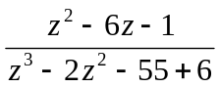in the region 3<Iz+2I<5. | [7M]
6. | a) | Find the image of the intimate stamp 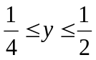under the transformation w=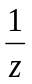. | [8M]
 | b) | Find the bilinear transformation which maps the points (-1,0,1) into the points (1,i,3i) | [7M]
7. | a) | Evaluation 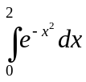using simpson’s rules by taking h=0.25. | [8M]
 | b) | Find y(0.2) by using Euler modified formula given that 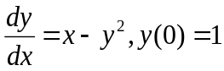. | [7M]
8. | a) | Evaluate 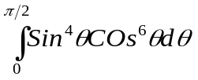 | [8M]
 | b) | Evaluate s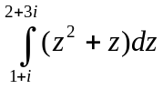along the line joining the points(1,1) and (2,3). | [7M]

-- 00 -- 00 –

